

Moshe Rimok

Liron Barel

**VolcanoRun**

**High Concept**

An active volcano is one of the coolest and scariest things on Earth. Our experience starts there. Our brave heros Ethan and Goblin fall into an active volcano and need to escape before they will get fried. In order to escape they must complete the challenges of the volcano and collect enough coins to pay the guard at the top.

**Gameplay:**

Overview  
Link to trailer: <https://www.youtube.com/watch?v=dU9ElXkmbE0>

Ethan and Goblin must run as fast as they can to escape the volcano before it erupts. They must get over the track ahead of them. They need to be careful not to hit the spike balls or get shot by the volcano bugs.

Player Objectives

* Avoid the obstacles
* Collect enough coins
* Complete mini games
* Get out alive!

**Core Gameplay Mechanics**

Characters – Meet our heroes!

Ethan Goblin

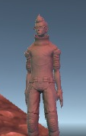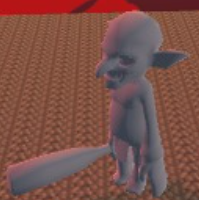

&

**Controllers**

|  |  |
| --- | --- |
| Player Action | Keyboard |
| Run | Arrows |
| Walk | Shift + Arrows |
| Jump | Space |
| Menu | Escape |
| Change Character | F |
| Change Camera Position | V |

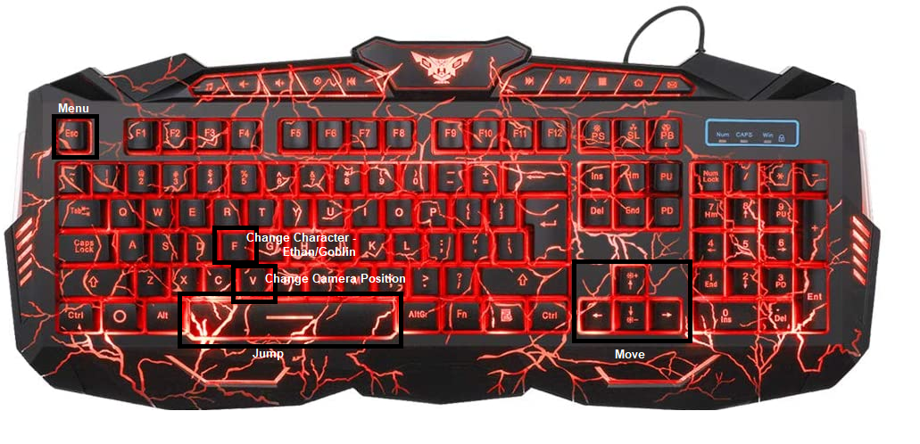

**Obstacles**

**The spikes of doom** – Giant spikes that on hit take 10 life points. Beware of them, or you will become swiss cheese..

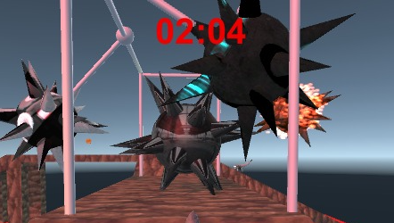

**Lava Bugs** – Deep ground bugs that lives inside the volcano and tries to protect it from intruders. If you get near them, they start shooting and every hit = 10 life points.

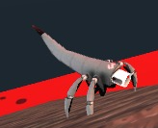

**Other Game Objects**

**Coins** - Ethan and Goblin need to pay the guard somehow…. However how will they get out of the volcano? The Guard Requires a 1000 coins to let them out.



**Portals** – Save points when the portal is blue and exit when its red.

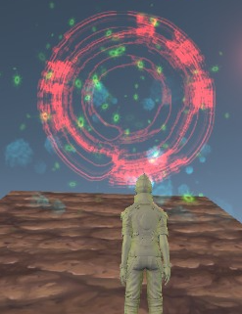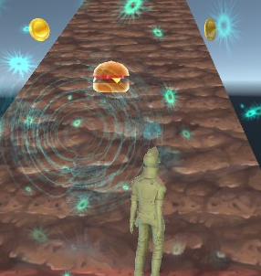

**Food** – How can we send our heroes on such a dangerous quest on empty stomachs?!? Food gain 10 health points. 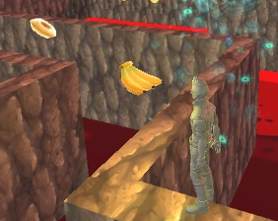

**Minigame Portal**

Portal to the mini games challenges of the volcano, in order to escape and get enough points they must be completed!

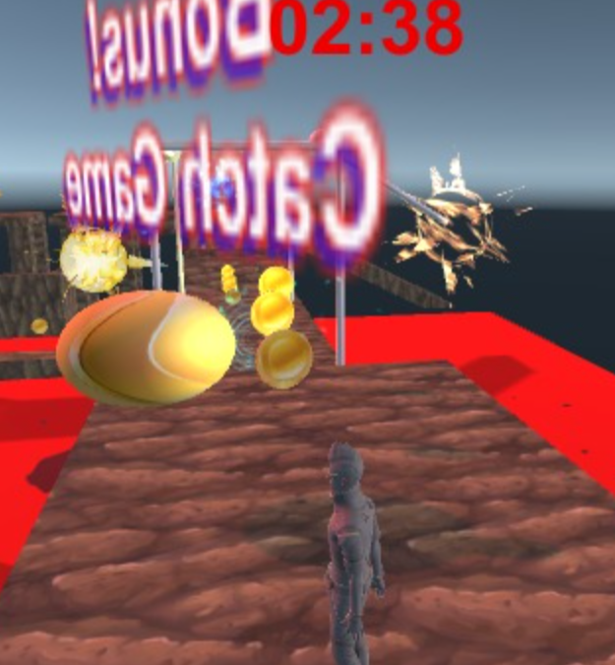

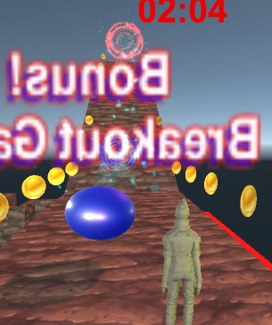

**Minigames**

**Breaking The Wall** – Gain extra points by breaking the walls in order to continue your journey. Every brick is 10 points and your only have 3 balls to use.

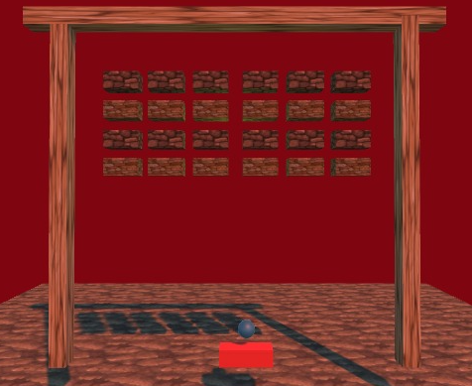

**MazeRunner** –

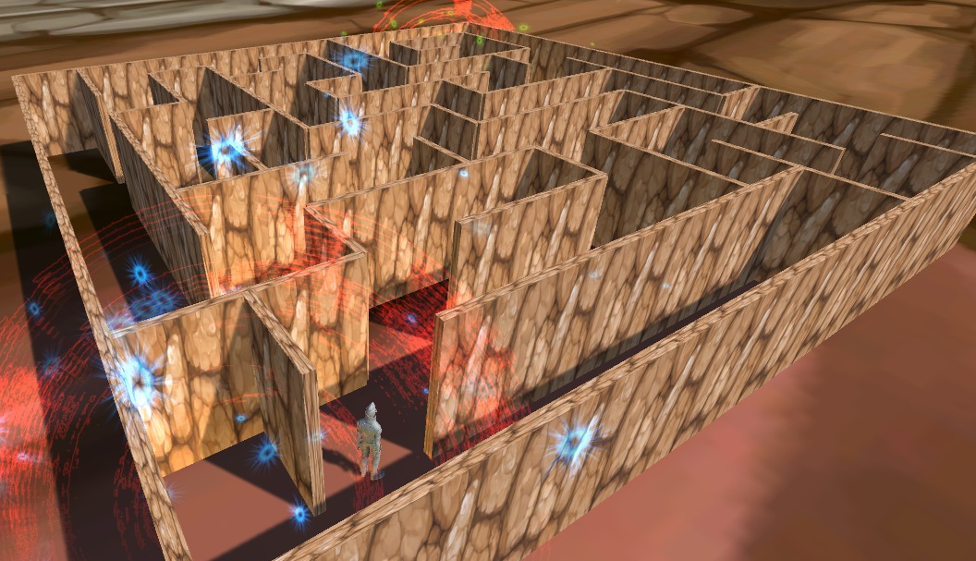Our heroes got stuck in a maze, it all looks the same!! They must get out of it fast in order to return to a safe place. Passing this challenge gain 100 coins!

**Known Bugs**

* When clicking escape and then continue the health bar resets to 100%.
* When entering the mazerunner minigame only if Goblin was the chosen character it changes to Ethan**.**